Student worksheet

9.2 The Moon reflects the Sun’s light

Pages 158–159 and 212

Phases of the Moon

1 Below is a diagram showing the phases of the moon.

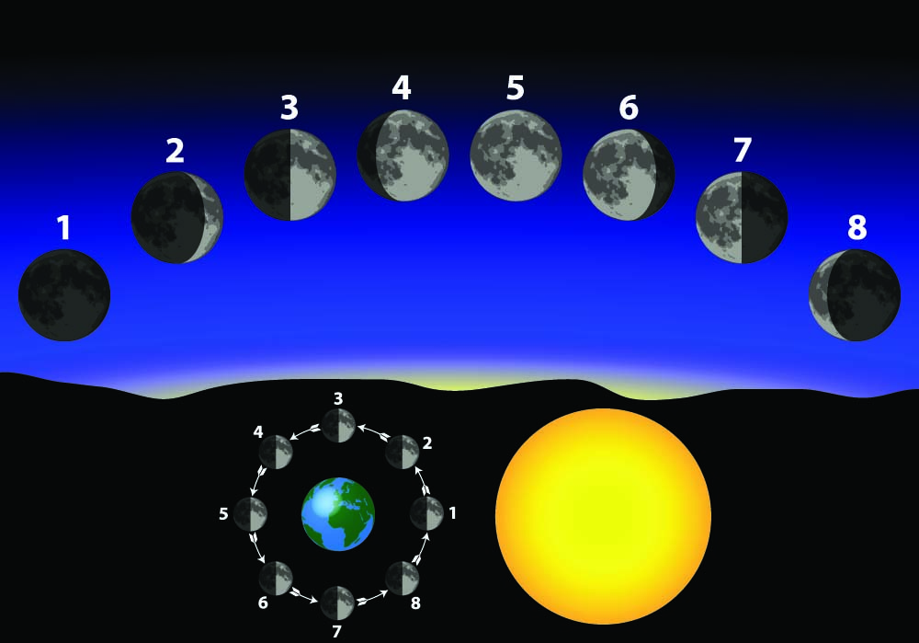

Complete the table below by filling in the phase of the Moon represented by each number in the diagram above.

|  |  |
| --- | --- |
| 1 |  |
| 2 |  |
| 3 |  |
| 4 |  |
| 5 |  |
| 6 |  |
| 7 |  |
| 8 |  |

2 a Why was Galileo Galilei referred to as an astronomer?

b How did Galileo observe the Moon?

c The Moon has large, flat plains called ‘seas’. What ‘active’ feature of the landscape would have created these ‘seas’?

d What happens to the Moon during the daytime?

3 a When did people first land on the Moon? _______________________________________

b Who were the first two people on the Moon?

c Describe the conditions the astronauts experienced on the Moon.

d What special equipment did they wear to cope with the conditions?

EXTEND YOUR UNDERSTANDING

4 Find out when the ‘seas’, large plains of solidified lava, were created on the Moon. Also research what the Earth was like at this time.